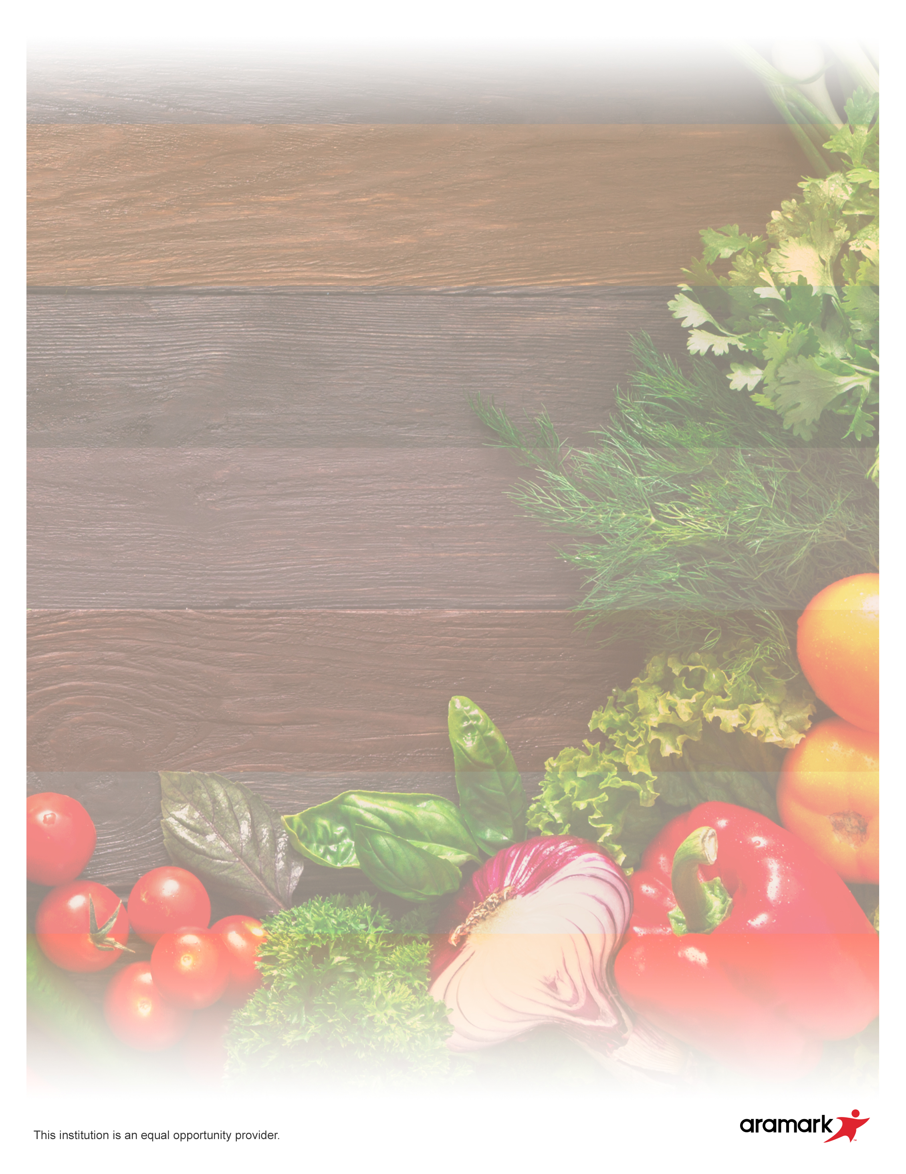

**Daily Options:**

PBJ grab & go lunch

Nacho Bar

Fresh Entrée salad with Chicken or Ham & roll

**Daily Grill:**

Chicken Patty

**Weekly Breakfast**

**Monday – Benefit bars w Fruit**

**Tuesday – Apple Frudel w/ Fruit**

**Wednesday – Pop tart & Bug Bites w/ Fruit**

**Thursday – Cinnis Mini w/ Fruit**

**Friday – Muffin & Scooby Snack w/ Fruit**

**15**

**16**

**17**

**18**

**19**

**22**

**23**

Cheeseburger

Baked Beans, Assorted Fruit

**24**

Chicken Patty Sandwich

Broccoli, Assorted Fruit

**25**

Pepperoni Pizza

Sweet Corn, Assorted Fruit

**26**

**8**

**9**

**10**

**11**

**12**

**1**

**2**

**3**

**4**

**5**

**Invent Learning Hub / Paramount Englewood**

**July 2019**

Country Fried steak sandwich

Sweet Corn, Fruit and Veggie Bar

**29**

Mini Corndogs

Roasted Carrots, Fruit and Veggie Bar

**30**

Cheese Pizza

Broccoli, Fruit and Veggie Bar

**31**